# Mutation tests

Add PITest Mutation Plugin in pom.xml

|  |
| --- |
| *<!--                   PITest Mutation Plugin                   -->*          <plugin>          <groupId>org.pitest</groupId>          <artifactId>pitest-maven</artifactId>          <version>1.5.0</version>          <dependencies>              <dependency>                  <groupId>org.pitest</groupId>                  <artifactId>pitest-junit5-plugin</artifactId>                  <version>0.12</version>              </dependency>          </dependencies>          <configuration>              <mutationThreshold>70</mutationThreshold> ## test fail if output less than 70%              <outputFormats>                  <outputFormat>XML</outputFormat> ## export report at XML                  <outputFormat>HTML</outputFormat>              </outputFormats>          </configuration>          </plugin>      </build> |

add code below before build stage:

|  |
| --- |
| stage('Mutation Tests - PIT') {              steps {                sh "mvn org.pitest:pitest-maven:mutationCoverage"              }              post {                always {                  pitmutation mutationStatsFile: '**/target/pit-reports/**/mutations.xml'                }              } |

This is a Jenkins pipeline code snippet that defines a stage called "Mutation Tests - PIT" which runs a mutation testing tool called Pitest.

The **`steps`** block describes the task to be performed in this stage. In this case, it runs the **`mvn`** command which executes the Pitest maven plugin to generate mutation coverage report.

`org.pitest:pitest-maven:mutationCoverage`: This is the specific goal being executed using the Pitest Maven plugin. The `mutationCoverage` goal is used to run the mutation tests and generate the mutation coverage report.

The **`post`** block defines a post-build action to be executed after the completion of the **`steps`** block. The **`always`** block is a post-build action that runs whether the previous steps succeeded or not.

The **`pitmutation`** command within the **`always`** block is a Jenkins plugin that parses the **`mutations.xml`** file generated by Pitest to calculate the mutation coverage statistics. The **`mutationStatsFile`** argument tells the plugin where to find the XML file.

Overall, this stage runs a mutation testing tool and generates a report using the Pitest maven plugin, followed by calculating and displaying the mutation coverage statistics using the Jenkins **`pitmutation`** plugin.

push new source code, jenkins have logs:

|  |
| --- |
| [ERROR] Failed to execute goal org.pitest:pitest-maven:1.5.0:mutationCoverage(default-cli) on project numeric: Mutation score of 40 is below threshold of 70-> [Help 1] |

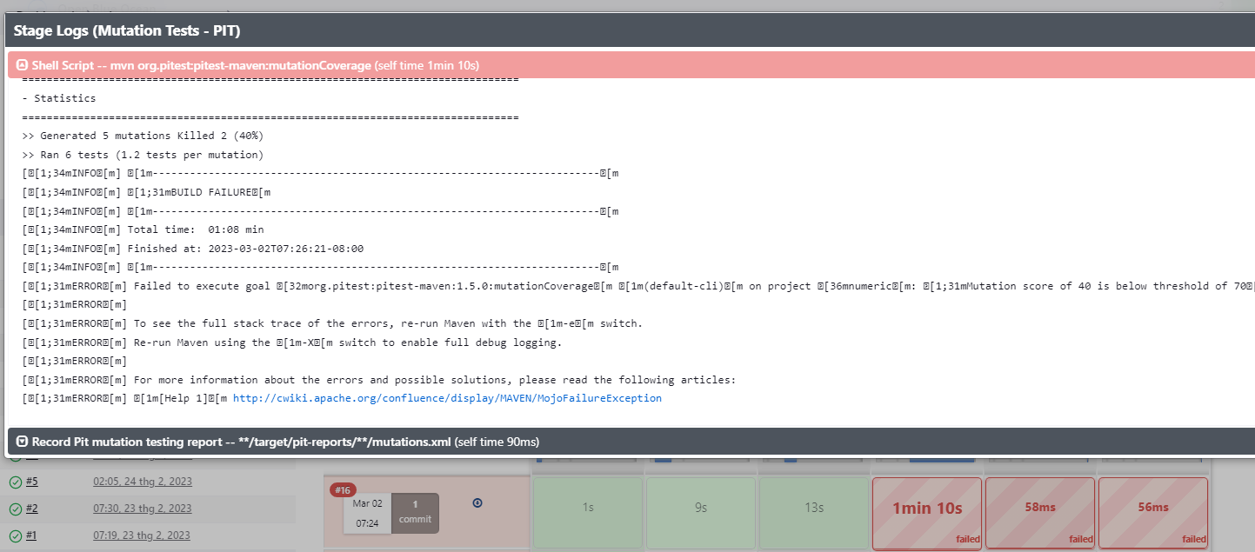

Dashboard 
Status 
devsecops-app-num 
Changes 
Console Output 
View as plain text 
Edit Build Information 
Delete build '#16' 
Polling Log 
Git Build Data 
Test Result 
Coverage Report 
PIT Mutation Report 
Modules 
Mutation Statistics 
Mutations Undetected Coverage 
40.0% (+40.0%) 
Components 
Name 
Module: null 
Mutations 
Undetected 
3 
Coverage 
40.0% 
+40.0% 

30 1 1. welcome : replaced return value with for 
return 
com/devsecops/NumericControllerScompere::welcome — SURVIVED 
31 
32 
33 
"Kubernetes DevSecOps" ; 
34 
public String int value) { 
35 
String message = 
36 2 1. compareToFifty : changed conditional boundary SURVIVED 
"Could not determine comparison" ; 
if (value > 50) { 
2. compareToFifty : negated conditional KILLED 
37 
38 
39 
mes sage 
else { 
mes sage 
— "Greater than 50" ; 
"Smaller than or equal to 50"; 

Change 3 test case become like below:

|  |
| --- |
| @Test      public void smallerThanOrEqualToFiftyMessage() throws Exception {          this.mockMvc.perform(get("/compare/50")).andDo(print()).andExpect(status().isOk())                  .andExpect(content().string("Smaller than or equal to 50"));      }      @Test      public void greaterThanFiftyMessage() throws Exception {          this.mockMvc.perform(get("/compare/51")).andDo(print()).andExpect(status().isOk())                  .andExpect(content().string("Greater than 50"));      }        @Test      public void welcomeMessage() throws Exception {          this.mockMvc.perform(get("/")).andDo(print()).andExpect(status().isOk())                  .andExpect(content().string("Kubernetes DevSecOps"));      } |

This is a JUnit test case written in Java that uses the Spring MVC Test framework.

The **`@Test`** annotation indicates that this method is a test case.

The name of the method **`welcomeMessage()`** is meant to describe the behavior being tested.

The **`throws Exception`** in the signature of the method indicate that this test may throw a generic **`Exception`**.

The **`this.mockMvc.perform(get("/"))`** is a method call in which we send an HTTP GET request to the application's root URL **`/`**.

The **`andDo(print())`** method is used to print the result of the request in the console.

The **`andExpect(status().isOk())`** method verifies that the response status code is 200 (OK).

The **`andExpect(content().string("Kubernetes DevSecOps"))`** method verifies that the response body contains the exact string "Kubernetes DevSecOps".

Overall, this test case is checking that the application's Welcome page displays the correct message "Kubernetes DevSecOps".

|  |
| --- |
| ll /var/lib/jenkins/workspace/devsecops-app-num/target/pit-reports/  total 12  drwxr-xr-x 3 jenkins jenkins 4096 Mar 2 21:49 ./  drwxr-xr-x 11 jenkins jenkins 4096 Mar 2 21:49 ../  drwxr-xr-x 3 jenkins jenkins 4096 Mar 2 21:49 202303022149/ |